Multiple choice section

|  |  |  |  |  |  |  |  |  |
| --- | --- | --- | --- | --- | --- | --- | --- | --- |
| Question | 1 | 2 | 3 | 4 | 5 | 6 | 7 | 8 |
| Answer | C | D | C | C | A | A | C | D |

Question 1 [10.2]

C

The object is reflected.

Question 2 [10.1]

D

A transformation can consist of any one of the following: translation, rotation or reflection.

Question 3 [10.4]

C

A combined transformation can consist of a reflection and then a translation. The other answers involve only one transformation.

Question 4 [10.5]

C

The letters A B have just one axis of symmetry. The letter H has two axes of symmetry.

Question 5 [10.7]

A

The number of cubes that can be placed over that position.

Question 6 [10.3]

A

The opposite of clockwise is anticlockwise.

360 – 10 = 350

Question 7 [10.1]

C

Opposite of left is right; opposite of up is down.

7 units right 🡺 7 units left

2 units down 🡺 2 units up

Question 8 [10.5]

D

A hexagon possesses both rotational and reflectional symmetry. It has an order of rotation equal to 6 and it possesses 6 axes of symmetry.

Multiple-choice total marks: *8*

Short answer section

Question 9 2 marks [10.5]

A isosceles trapezium and a kite have exactly one axis of symmetry.

Question 10 2 marks [10.3]

A rotation occurs when a figure is turned or rotated around a fixed point. A rotation can occur in a clockwise or anticlockwise direction.

Question 11 2 marks [10.1]

5 units right and 2 unit down.

Question 12 3 marks [10.1]

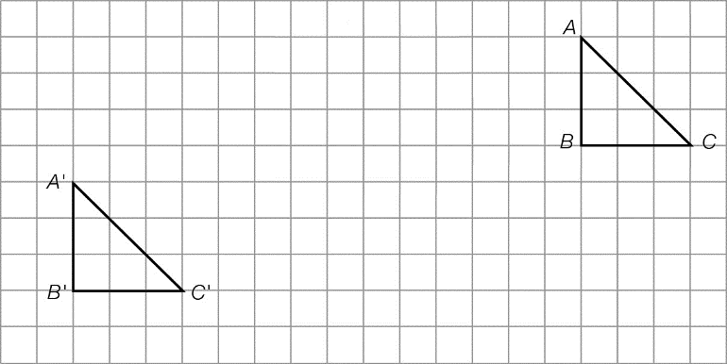

Question 13 6 marks [10.2]

(a)–(b)

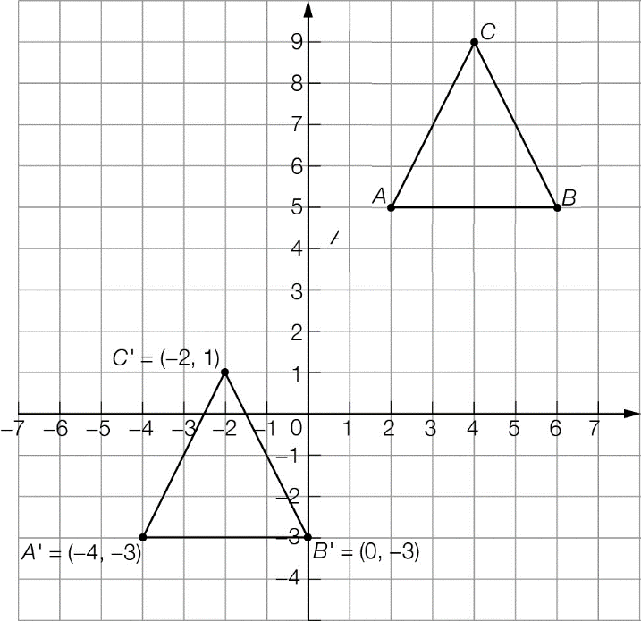

(c) Coordinates: A' (-4, -3) B' (0, -3) C' (-2, 1)

Question 14 2 marks [10.2]

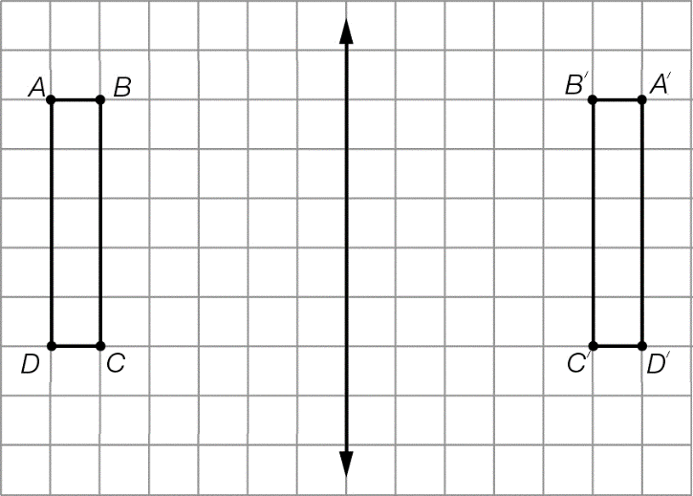

Question 15 2 marks [10.3]

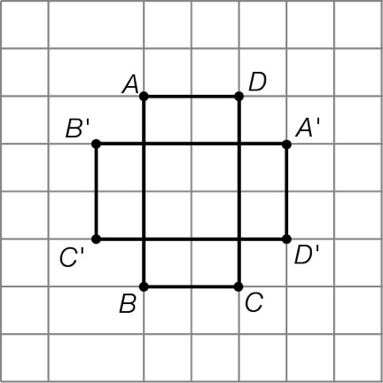

Question 16 2 marks [10.5]

(a) 1 axis of symmetry

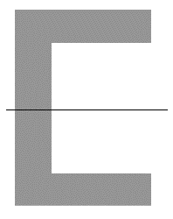

(b) 8 axis of symmetry

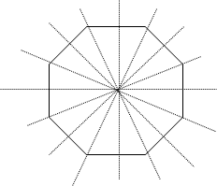

Question 17 2 marks [10.5]

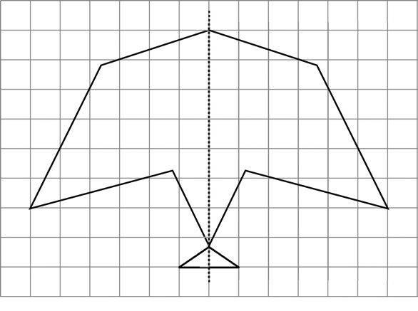

Question 18 4 marks [10.5]

**(a)** The left half of Figure 1 forms the left of Figure 2. The right half of Figure 2 is formed from the mirror image of the left half of Figure 1.

**(b)** The right half of Figure 1 forms the right of Figure 3. The left half of Figure 3 is formed from the mirror image of the right half of Figure 1.

Question 19 1 marks [10.6]

Top layer = 2 cubes

Bottom layer = 9 cubes

2 + 9 = 11 cubes

Question 20 2 marks [10.7]

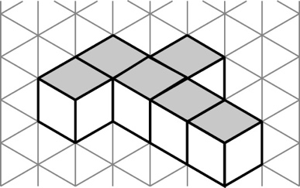

Question 21 3 marks [10.7]

|  |  |  |
| --- | --- | --- |
| (a) top view  Macintosh HD:Users:lizwaud:Desktop:PM7_eBook:Batch 1 commenced:Artwork_CORRECTED_041016_Use this:Ch10:PM2e_07_EB_10_ATS_01.jpg | (b) front view  Macintosh HD:Users:lizwaud:Desktop:PM7_eBook:Batch 1 commenced:Artwork_CORRECTED_041016_Use this:Ch10:PM2e_07_EB_10_ATS_02.jpg | (c) side view  PM7_SmB_SSa10_12a |

Question 22 4 marks [10.7]

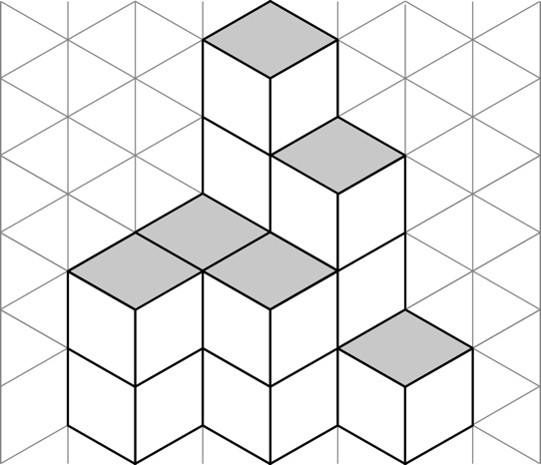

Short answer total: 37

Extended answer section

Question 23 3 marks [10.4]

(a) A'B'C'D' has been translated 4 units to the right and 1 unit down.

(b) A"B"C"D" has been rotated 45° anticlockwise.

Question 24 4 marks [10.5]

Any four of:

8000008 8088808 8080808 8008008  
8800088 8888888 8880888 8808088

Question 25 6 marks [10.4]

A1 🡺 rotated 180° anticlockwise

A2 🡺 translated up one unit and translated right one unit 🡺 rotated 180° clockwise

B1 🡺 translated down one unit 🡺 rotated 90° anticlockwise

B2 🡺 translated left one unit

Question 26 6 marks [10.2]

(a)–(c)

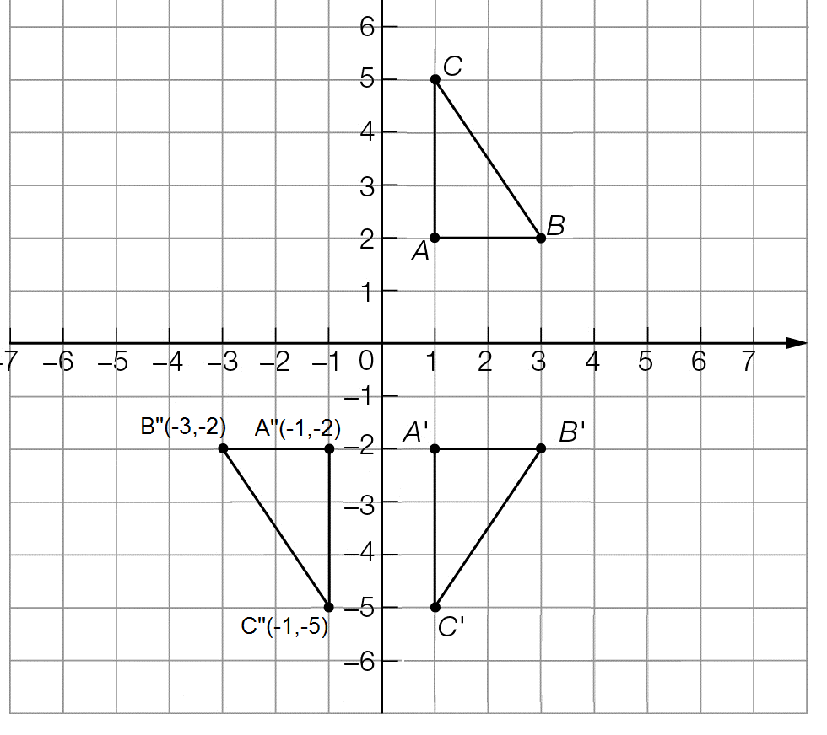

(d) coordinates A" (-1, -2) B" (-3, -2) C" (-1, -5)

Extended answer total: 19

TOTAL test marks: 64